4. METAL FORMING
METAL FORMING: Large set of manufacturing processes in which the material is deformed plastically to take the shape of the die geometry. $σ_{yt}≤ σ_{Applied}<σ_{ut}$
BASIC TYPES OF DEFORMATION PROCESSES
BULK DEFORMATION | SHEET METAL WORKING/ PRESS WORKING
- Rolling  - Wire or Tube Drawing  - Extrusion  - Forging | - Bending  - Deep Drawing  - Cutting  - Miscellaneous Processes

ADVANTAGES | LIMITATIONS
- Material Wastage is zero or negligible.  - Grains can orient in required direction.  - In Cold working strength and hardness increases.  - In hot working malleability and ductility increases. | - Force and energy required is very high.  - Highly automated machines required, which are costly.  - Manufacturing of dies is difficult and costly.  - Except forging all other processes can only manufacture uniformly cross-section components.  - Undercut and cross holes are not possible to produce.
Three Philosophy by which deformation can be understood: 1) Dislocation, 2) Slipping, 3) Twining.
RECRYSTALLIZATION: It’s a process by which deformed grains are replaced by a new set of defect-free grains that nucleate and grow until the original grains have been entirely consumed.
RECRYSTALLIZATION TEMPERATURE: Temperature at which recrystallization takes place.
COLD WORKING | HOT WORKING
Temp. < Recrystallization Temp. | Temp. > Recrystallization Temp.
$$T_{CW}<0.3T_{Melting}$$ | $$T_{HW}>(0.5 or 0.6 )T_{Melting}$$
μ = 0.1 to 0.2 | μ = 0.6 to 0.6. Friction is high due to Oxidation Formation (Rough Surface is generated) And high Sticking friction between billet and tool due to temporary bonding (because of high temperature).
Good Quality of surface finish. | Poor Quality of surface finish.
Better Dimensional Accuracy | Poor Dimensional Accuracy.
High Forces Required | Less Forces Required due to material softening at high Temperature.
Strength and Hardness Increases. | Strength and Hardness Decreases.
Ductility and Malleability Decreases. | Ductility and Malleability Increases. Due to recrystallization.
WORM WORKING: $0.3T_{Melting}<T_{HW}<(0.5 or 0.6 )T_{Melting}$
Recrystallization Temp = (1/3 to 1/2) * Melting point Temperature
Lead, Tin, Zinc & Cadmium has Recrystallization Temperature $≤$ Room Temperature.
And Titanium has Melting point Temperature 3400 $°$C.
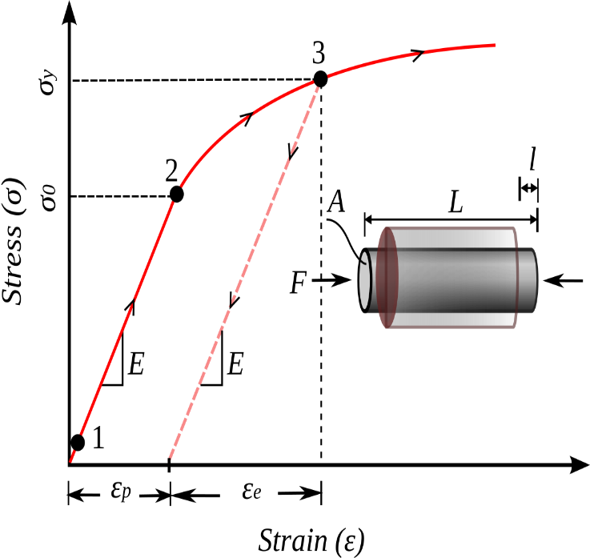 | 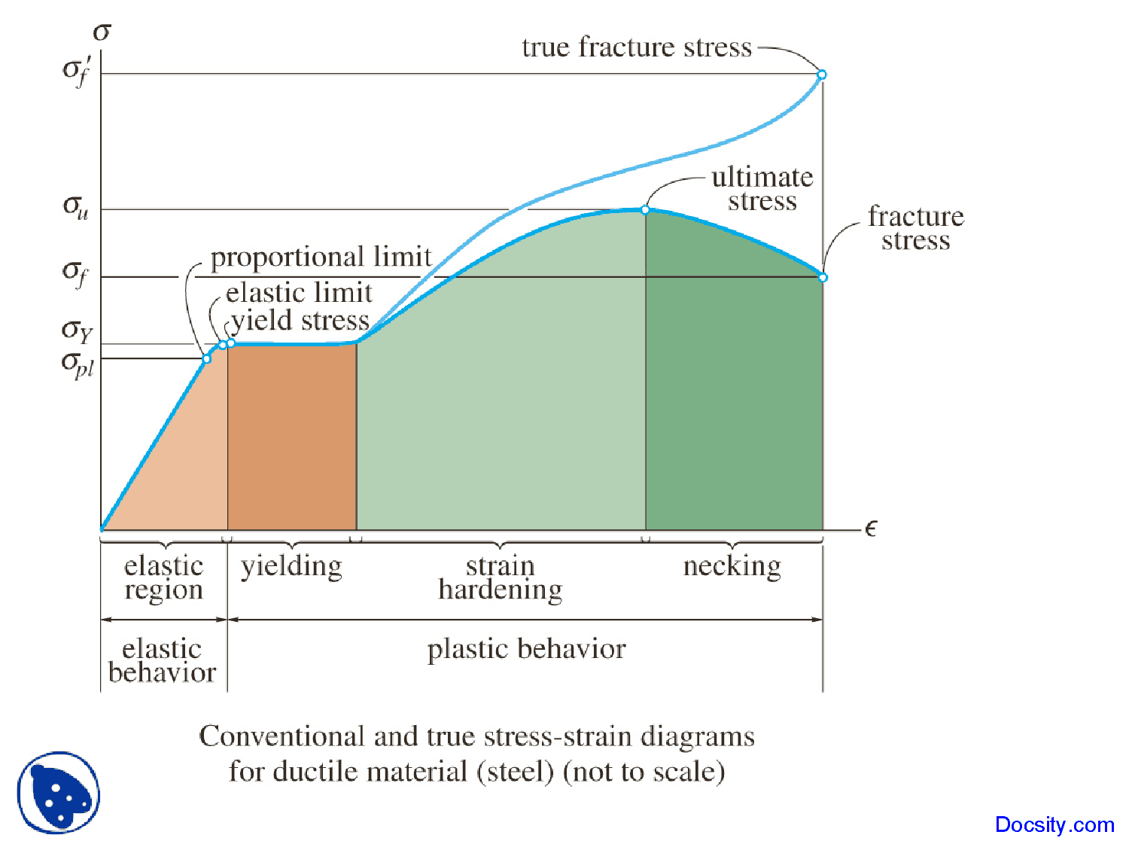
Due to sudden removal of load, After Spring back Action $ε_{body}=ε_{elastic}=ε_{total}-ε_{plastic}$
Due to maintaining load for some time, $ε_{body}=ε_{total}$ and $ε_{elastic}=0$.
$$Total Strain ε_{total}=ε_{plastic}+ε_{elastic}=ε_{P}+\frac{σ_{applied}}{E} \left[∵Slope E=\frac{∆σ}{∆ε}=\frac{σ}{ε_{elastic}}=\frac{σ_{P.L.}}{ε_{P.L}}\right]$$
STRESS STRAIN DIAGRAM FOR COMPRESSIVE LOADING: Assumed for all materials that $σ_{yt}=σ_{yc}$
Engineering Stress $σ_{E}={Load Applied}/{Initial Area}$ | True Stress $σ_{T}={Load Applied}/{Instantaneous Area}$
$$σ_{T}=\frac{F}{A_{f}}=σ_{E}\frac{A_{i}}{A_{f}}=σ_{E}\frac{d_{i}^{2}}{d_{f}^{2}}=σ_{E}\frac{l_{f}}{l_{i}}=σ_{E}\left(1+ε_{E}\right)$$  $$True Strain ε_{T}=\int_{L_{0}}^{L_{1}}{\frac{dl}{L}}=\ln\left(\frac{L_{1}}{L_{0}}\right)=\ln\left(\frac{A_{i}}{A_{f}}\right)=2\ln\left(\frac{d_{i}}{d_{f}}\right)=\ln\left(1+ε_{E}\right)$$ |  | $$\left(∵ σ_{E}=\frac{F}{A_{i}},A_{i}l_{i}=A_{f}l_{f}\right)$$  Up to proportionality limit,  $σ_{T}=σ_{E}$ and $ε_{T}=ε_{E}$

DUCTILITY: It’s Ability of material, that deform plastically up to the failure point by applying tensile load. Making wires. | MALLEABILITY: It’s Ability of material, that deform plastically in lateral direction by applying compressive load up to the failure point. Making Thin Sheets.
Measure of Ductility/ Malleability:
- $\% Increase/Decrease in Length=±\left(\frac{l_{f}-l_{i}}{l_{f}}\right)*100=ϵ*100$
- $\% Increase/Decrease in C/S Area=±\left(\frac{A_{i}-A_{f}}{A_{i}}\right)*100=\left(1-\frac{d_{f}^{2}}{d_{i}^{2}}\right)*100$
POWER LAW EQUATION OR STRAIN HARDENING LAW
The power law gives the relationship between true stress and true strain prior to the necking. It’s valid up to ultimate point (Necking).  $$σ_{T}=Kε_{T}^{n} (Valid in the region σ_{yt}≤ σ_{Applied}<σ_{ut})$$  $$n={∆\log{σ_{T}}}/{∆\log{ε_{T}}}$$ | Where, K = Constant of Material/ Strain hardening constant,  $n=$Strain/ Work Hardening Exponent. 0 < n < 1  For $ε_{T}$= 1, K= $σ_{T}$
FLOW STRESS: It’s defined as the instantaneous value of stress required to continue plastically deforming the material - to keep the metal flowing. The flow stress for a given material in continuum mechanics is dependent upon the temperature, true strain, and strain rate. $σ_{yt}≤ σ_{Flow Stress}<σ_{ut}$
$$\overline{Υ}={\left(\int_{0}^{ε}{σ_{T} dε_{T}}\right)}/{ε_{T}}=\frac{Kε_{T}^{n}}{n+1}$$ | $\overline{Υ}$= Average Flow stress,  $$σ_{yt}≤\overline{Υ}<σ_{ut}$$
Flow Stress = Flow Strength = Yield Stress = Yield Strength (For strain hardened material $σ_{yt}=\overline{Υ}$)
STRAIN RATE $(\dot{ε}):$ Rate of change of strain with respect to time. $\dot{ε}={dε}/{dt}$ (Unit: s⁻¹)
VOLUME CONSTANCY: Actually, change of volume in metal forming process is 0.1% which in negligible. Hence, for all calculation purpose Volume is taken Constant.
SLAB | DISC
E.g. Strip, Plate, Sheet etc… | E.g. Cylinder, Wire, Rod etc…

PERFECTLY ELASTIC MATERIAL | RIGID PERFECTLY PLASTIC | LINEAR ELASTIC AND PERFECTLY PLASTIC
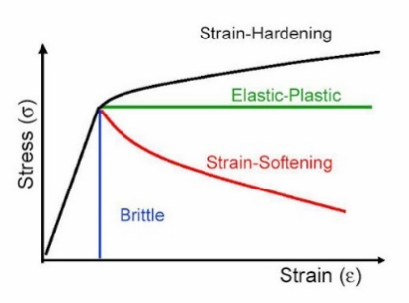 | 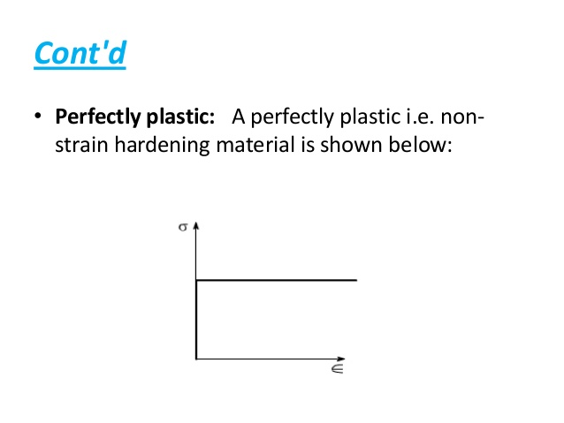 | 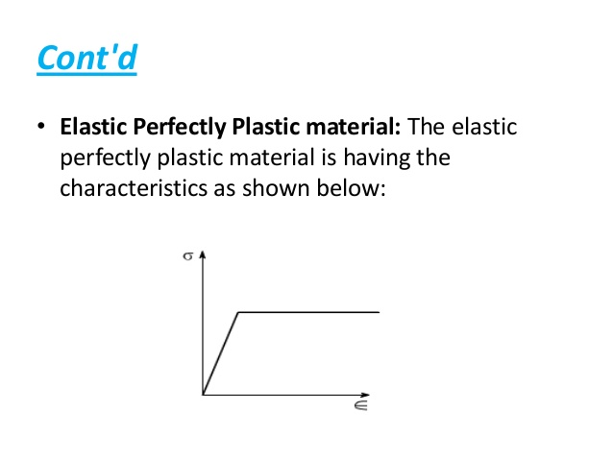
RIGID, LINEAR STRAIN HARDENED | ELASTIC AND LINEAR STRAIN HARDENED
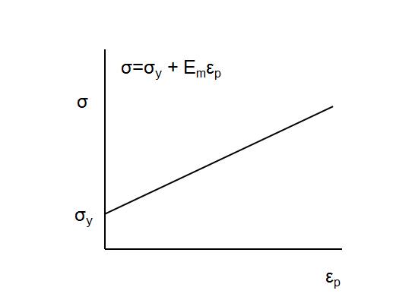 | 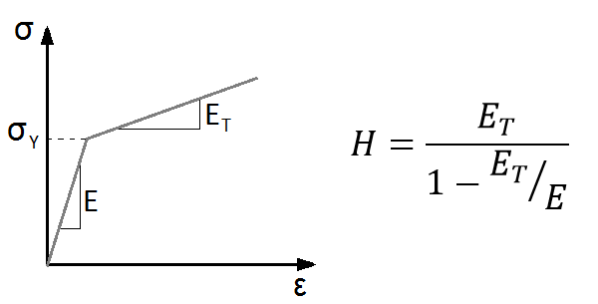 | For perfectly elastic material, n = 1,  For rigid perfectly plastic, n = 0,  For rigid, linear strain hardening, $σ=σ_{yt}+Hε$.  Where, H = Plastic Modulus.

ROLLING: In metalworking, rolling is a metal forming process in which metal stock is passed through one or more pairs of rolls to reduce the thickness and to make the thickness uniform.
THING TO SATISFY BEFORE ROLLING:
- Dia. Of Rollers: $D_{A}=D_{B}=D$.  - RPM of rollers:$N_{A}=N_{B}=N$. Else Alligator effect is generated. And stripping of the material takes place.  - Both rollers rotate in opposite direction.  - Centre of cylindrical Rollers must be arranged in single vertical line. Else Bending happens. | - Roller’s must be perfectly cylinder.  - $L_{Roller}>b_{Strip}$  - V > V₀. Because of friction between roller and strip material, drag into rolling will be happed.
ASSUMPTIONS IN PLANE STRAIN ROLLING ANALYSIS:
$∆Volume=0$ (Incompressible material) ($μ=0.5$) | $$b_{0}=b_{1}=b$$
ABBREVIATIONS:
$∆H=H_{0}-H_{1}$, And $∆H=f(D,α)$  $$μ=\tan{β},And ,V(mm/s)=\frac{πD(mm)N(rpm)}{60}$$  From Volume Constancy: $H_{0}b_{0}l_{0}=H_{1}b_{1}l_{1}$  From Discharge Constancy: $H_{0}b_{0}V_{0}=H_{1}b_{1}V_{1}$  $$\frac{H_{0}}{H_{1}}=\frac{l_{1}}{l_{0}}=\frac{V_{1}}{V_{0}}>1$$  $$V_{0}<V<V_{1},$$  Hence, Across Deformation Zone,  - Compressive Stress increases,  - Thickness decreases,  - Velocity Increases. | $D$ = Dia. Of Rollers $,$  R = Radius of Rollers,  $H_{0}\& H_{1}$= Thickness before and after rolling,  $b_{0},b_{1},b,W_{0},W_{1},W$= Width of Plates.  $$b_{0}=b_{1}=b$$  $V_{0}\& V_{1}$= Velocities of plate before and after rolling,  V = Surface Velocity of roller,  $β$= Friction Angle,  $μ$=Coefficient of friction,  $l_{0},l_{1}$= Length of plate before and after rolling,  $α$ = Bite Angle/ Deformation Angle,
Across the defamation zone, some point yield stress becomes flow stress and material starts flowing plastically form that point. At this point/ Plane, $V_{0}=V$ and it’s called as neutral plane. This plane divides entire deformation zone into two zone 1) Backward Zone, 2) Forward/ Leading Zone.
$$Slip ∝Relative Velocity$$
$$\% of Max. Backward Slip=\left(\frac{V-V_{0}}{V}\right)100$$ | $$\% of Max. Forward Slip=\left(\frac{V_{1}-V}{V}\right)100$$ | Slip at neutral plane = 0
FRICTION PROFILE: Friction on the plate is called friction profile.
$$Pressure in Rolling/ Stress in the Strip ∝{Slip}^{-1}$$
From $∆O_{1}AC$,  $$\cos{α}=\frac{R-\left({∆H}/2\right)}{R} ⇒∆H=D(1-\cos{α})$$  Hence, $∆H=f\left(D,α\right)$  Arc Length of Plastic Deformation Zone: $Arc AB=Rα$  Arc AB = Length of contact between roller and strip = L | From $∆O_{1}AC$, Form Pythagoras theorem,  $$L=\sqrt{R∆H-{\left({∆H}/4\right)}^{2}}$$  $$L=\sqrt{R∆H} \left[∵∆H≪<R\right]$$  Projected Area $= Lb=LW$  From $∆O_{1}AC,$  $$\tan{α}= \sqrt{{∆H}/R}$$
MAXIMUM REDUCTION POSSIBLE PER PASS:
From the figure, $R_{f}=f\cos{α}-N\sin{α}$  For Dragging Strip automatically,  $$R_{f}≥0 ⇒ f/N≥\tan{α}$$  Here, $f/N=μ=\tan{β}$  Hence, $β≥α$.  Hence $α_{max}=β$ And hence, at $α_{max}, {∆H}_{max}$. | Hence, $\tan{β}= \sqrt{{{∆H}_{max}}/R}$ (From Previous Eq.)  $$⇒{∆H}_{max}=μ^{2}R$$  No. of Pass Required for given reduction:  $$n_{passes}={∆H}/{{∆H}_{max}}$$
TANDEM ROLLING MILL: No. of Rollers are arranged in the single rolling direction for successive reduction.
ROLL SEPARATING DISTANCE: $RSD=O_{1}O_{2}=D+H_{1}$
ELONGATION FACTOR /  COEFFICIENT OF ELONGATION (K): | $$K=\frac{l_{1}}{l_{0}}=\frac{H_{0}W_{0}}{H_{1}W_{1}}=\frac{V_{1}}{V_{0}}=\frac{A_{0}}{A_{1}}$$ | For n unequal elongation in Tandem Rolling mill,  $$K_{1}K_{2}K_{3}…={H_{0}}/{H_{n}}$$  For $K_{1}=K_{2}=K_{3}=K$, $K^{n}={H_{0}}/{H_{n}}$.
TRUE STRAIN IN ROLLING: | $$ε=\ln{\frac{l_{1}}{l_{0}}}$$ | Here, Form the previous eq. we can make more equations.
PRESSURE IN ROLLING: $F_{Avg}=P_{Avg}*Projected Area=P_{Avg}*WL$
ROLL SEPARATING FORCE (RSF): Due to RSF, rollers tries to buckle or the rolled element has non uniform thickness across the width direction. It may be observed that due to excessive RSF RSD increases. Hence, problems such as efficiency decreases and productivity decreases. To reduce RSF Convex or Cambering rollers are selected Which is shown in figure. | 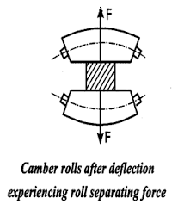
METHODS TO REDUCE RSF:
- Perform Hot Rolling. Due to hot rolling Yield Stress Decreases.  - Decreases Dia. Of Cylindrical rollers. Due to less contact area. | - Appling Front & Back Tension.  - Decrease μ up to $β≥α$.
AVERAGE ROLLING FORCE:
Methods to calculate Flow Stress:$True Strain ε=\ln{\frac{H_{0}}{H_{1}}} And σ_{T}=Kε_{T}^{n}$ And $\overline{Υ}={\left(\int_{0}^{ε}{σ_{T} dε_{T}}\right)}/{ε_{T}}=\frac{Kε_{T}^{n}}{n+1}$
CASE I: $P_{Avg}$ is given.  $$F_{Avg}=P_{Avg}*WL$$  For continuously flowing/ Deformation of the body, $P_{Avg}=\overline{Υ}$  Hence, $F_{Avg}=\overline{Υ}*WL$ | CASE II: Yield Stress is given.  For Plane Strain Condition:  From Distortion Energy Theory, $Υ^{'}=\left(2/{\sqrt{3}}\right)σ_{yt}$  Where $Υ^{'}=$Plain Strain Flow Strain.  $\overline{Υ'}=$ Avg. Flow Stress in Plain Strain.  $$F_{Avg}=\overline{Υ'}*WL$$ | CASE III: μ is given.  $$H_{Avg.}={H_{0}+H_{1}}/2$$  $$Avg. Stress= \overline{Υ'}\left[1+\frac{μL}{4H_{Avg.}}\right]$$  $$F_{Avg}=Avg. Stress*WL$$
AVERAGE ROLLING POWER:
$$Power=2\left(τ×ω\right)$$  $$τ=F_{Avg} a, Where a=λL$$  $$ω=\frac{2πN}{60}$$ | Where,$a$ = Distance where Avg. force acting,  λ = Moment Arm Factor = 0.5 (Default)  = 0.5 For Hot Rolling  = 0.4 For Cold Rolling

TYPES OF ROLLING MILLS
Two High Rolling  - RSF is high.  - Productivity is less.  - Less Efficiency.  - Non-Uniform Thickness. | Three High Rolling  Only productivity increases.  - Middle Roller need to very hard.  - All other problems remain same. | Four High Rolling  productivity Same and Buckling of rollers eliminated.  - All rollers need to be in single line. |  | Cluster Rolling  productivity Same but high amount of reduction possible.
Tandem Rolling  Productivity is high. Due to successive reduction in in each pass |  |  | Planetary Rolling  Due to less contacting area, RSF more decreases

DEFECTS IN ROLLING
Wave Edges | Cracks | Alligator Effect
Due to change in thickness along width direction. Due to in-isotropic property, unequal plastic deformation.  Spreading cause Wave Effect along the Width direction. | Due to wave effects bending stress is extreme hence crack propagates there. | Due to difference in Both rollers drag/Shear force are different. And due to sliding of layers, Separation takes place. Due to blow holes, this effect may take place.

WIRE DRAWING: Wire drawing is a metalworking process used to reduce the cross-section of a wire by pulling the wire through a single, or series of, drawing die. It generally carried out by Cold Working.
ABBREVIATIONS:
Coefficient of elongation/Draft: $K={A_{0}}/{A_{1}}$  $$\% Decrease in C/S Area=±\left(\frac{A_{0}-A_{1}}{A_{0}}\right)*100$$  From the Volume constancy:  $$\frac{l_{1}}{l_{0}}=\frac{A_{0}}{A_{1}}$$  𝑇𝑟𝑢𝑒 𝑆𝑡𝑟𝑎𝑖𝑛 𝜀=ln 𝐾 | $d_{0}\& d_{1}$= Dia. before and after wire drawing,  $A_{0}\& A_{1}$= C/s Area before and after wire drawing,  $V_{0}\& V_{1}$= Velocities of wire before and after drawing,  $μ$ =Coefficient of friction,  $l_{0},l_{1}$= Length of plate before and after drawing,  $2α$ = Full Die Angle,  $α$ =Half/ Semi Die Angle.  L= Die. Land Constant.
For constant L: $\% Decrease in C/S Area∝ α$  $$Load Required for drawing∝ α$$ | For constant % Decrease in C/S Area: L and $α$ Varies
DIFFERENT ZONES AND TYPES OF LUBRICATIONS:
- Deformation Zone: Deformation takes place in this zone. Here Friction force and normal Forces acting at the surface of die or Rolling metal.  - Entry Zone: Provides Lubrication. | - Sizing Zone: After Plastic deformation there might by some elastic deformation. This zone reduces elastic deformation.  - Exit Zone: Prevents worker form hazard(Hot Lubs.)
TYPES OF LUBRICATION | COLOUR OF WIRE
No Lubrication or Gas Lubrication | Black or Blunt Surface
Liquid Lubrication | Metallic or Dull
Solid Powder Lubrication | Silvery or Shiny
STEPS IN WIRE DRAWING:
- Rotary Swaging Operation: Initial Section is prepared to feed material into die.  - Acid Pickling: It Removes Oxides, Scale, Corrosions and Burns.  - Alkaline Cleaning: It Removes Oil and Greece. | - Phosphate Coting: It Reduces Friction during drawing.  - Lubrication: Three types of lubrications can be provided as mentioned previously.
Here, Tri Axial Stress is applied during Wire Drawing Operation. Because on the element of the of wire, (Tensile stress + Compressive Stress + Shear Stress) present.
CASE I: Ideal Wire Drawing Stress (No Friction & No Redundant Work involves).
For Extrusion Process:  $$u=\int_{0}^{ε}{σ_{T}dε}=\overline{Υ}ε\left[∵Strain Eq. and Strain Hardaning Eq.\right]$$  Work Done on the Wire = $E=A_{0}L_{0}u=A_{0}L_{0}\overline{Υ}\ln\left({A_{0}}/{A_{1}}\right)$  Work Done on the Wire = $F L_{0}$  Hence, Ideal Load $F=A_{0}\overline{Υ}\ln\left({A_{0}}/{A_{1}}\right)$  Ideal Stress $σ_{d} =\overline{Υ}\ln\left({A_{0}}/{A_{1}}\right)$= Ideal Extrusion pressure. | $σ_{d}$= Drawing Stress,  $u$ = Specific Energy or Strain Energy per unit volume due to drawing.  E = Internal Energy,  F = External Force Applied for Extrusion,  $\overline{Υ}$= Average Flow stress of the material,
Hence, For Wire Drawing Process for Strain Hardened material,
Ideal Stress $σ_{d}=\overline{Υ}\ln\left({A_{0}}/{A_{1}}\right)$ | Ideal Load $F=A_{1}\overline{Υ}\ln\left({A_{0}}/{A_{1}}\right)$
For Ideal/ Perfectly Plastic Material: $\overline{Υ}=Υ=σ_{yt}$
CASE II: $μ$ is given. Friction is considered.
From the Slab Analysis,  $$σ_{d}=\overline{Υ}\left(\frac{1+β}{β}\right)\left[1-{\left(\frac{A_{1}}{A_{0}}\right)}^{β}\right]$$  $$Drawing Load F=A_{1}σ_{d}$$ | Where, $α$ =Half/ Semi Die Angle.  $β=μ\cot{α}$,  $μ$ = Coefficient of friction,  Power required for Drawing P = Drawing (Load*Velocity)
Here, if Strain hardening constants are not given than directly put the value of $\overline{Υ}$, Else calculate $\overline{Υ}$.
MAXIMUM REDUCTION POSSIBLE PER PASS:
Necessary Condition: $σ_{d}=Yield Stress of material \left(Drawing Material\right) at minimum cross section(At Exit)$
$$σ_{d}={\overline{Υ}}_{Exit}$$
For Ideal Drawing ($μ$ = 0) & Plastic Material,  $${A_{0}}/{A_{1}}=e$$  Hence, maximum % reduction possible = 63.2% | For Ideal Drawing ($μ$ = 0) & Hardened Material,  $${A_{0}}/{A_{1}}=e^{n+1}$$  Hence, maximum % reduction possible < 63.2%

DIE PRESSURE $P=\overline{Υ}-σ_{d}$
At Entry Point: $σ_{d}=0$, $P=σ_{yt}$ | At Exit: $P=σ_{yt@exit}-σ_{d}$
Applications of Wire Drawing:

- Electric Wiring.
- Cables
- Tension Loaded Structures.
- Springs.
- Paper Clips.
- Spokes of wheels.
- Stringed musical instruments.

TUBE DRAWING: Tube drawing is a process to size a tube by shrinking a large diameter tube into a smaller one, by drawing the tube through a die. This process produces high-quality tubing with precise dimensions, good surface finish, and the added strength of cold working.
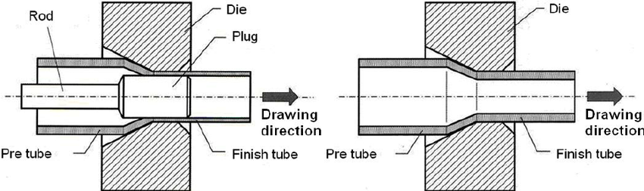 | 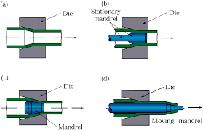
Types of Tube Drawing:1) Without Mandrel: Interial Surface Quality is poor, 2) Stationary Mandrel, 3) Floating Mandrel, 4) Moving Mandrel.
TYPES OF MANDRIL USED
Cylindrical Mandrel$(γ=0)$ | Conical Mandrel$(γ≠0)$
Used To produce Same inside Diameter. | Used To produce reduced inside Diameter.
ANALYSIS:
$$σ_{d}=\overline{Υ}\left(\frac{1+β}{β}\right)\left[1-{\left(\frac{h_{1}}{h_{0}}\right)}^{β}\right]$$  $$β=\frac{μ_{1}±μ_{2}}{\tan{α}-\tan{γ}}$$  - For ( Fixed Plug or Stationary Mandrel) And (Floating Mandrel): $β=\frac{μ_{1}+μ_{2}}{\tan{α}-\tan{γ}}$  Cylindrical Mandrel Can’t use as Floating Mandrel.  - For Movable Mandrel: $β=\frac{μ_{1}-μ_{2}}{\tan{α}-\tan{γ}}$  Mandrel And Tube Velocity Both are same at the exit. And At the deformation Zone Rod Velocity is grater than Tube. | $2α$ = Full Die Angle,  $α$ =Half/ Semi Die Angle,  $2γ$ = Cone Angle of Mandrel,  $γ$ =Half/ Semi Cone Angle,  $σ_{d}$= Drawing Stress,  $H_{0}\& H_{1}$= Thickness before and after rolling,  $μ_{1}$ = Friction Between Outside Surface of tube and Die,  $μ_{2}$ = Friction Between Inside Surface of tube and Die,
For Ideal Tube Drawing ($β=0$ or$μ=0 or μ_{1}=μ_{2}=μ$):
For Ideal Plastic: Ideal Stress $σ_{d}=Υ\ln\left({H_{1}}/{H_{0}}\right)$ | For Strain Harden: Ideal Stress $σ_{d}=\overline{Υ}\ln\left({H_{1}}/{H_{0}}\right)$

EXTRUSION: Extrusion is a metal forming process in which metal or work piece is forced to flow through a die to reduce its cross section or convert it into desire shape. This process is extensively used in pipes and steel rods manufacturing. The force used to extrude the work piece is compressive in nature. This is hot working process.
This process produce Hydrostatic Compressive load. This performs in only one stroke.
From Volume Constancy:  $$H_{0}b_{0}l_{0}=H_{1}b_{1}l_{1}$$  From Discharge Constancy:  $$\frac{A_{0}}{A_{1}}=\frac{H_{0}}{H_{1}}=\frac{l_{1}}{l_{0}}=\frac{V_{1}}{V_{0}}>1$$  Extrusion Ratio/Draft:  $$K={A_{0}}/{A_{1}}$$  $$\% Decrease in C/S Area=\left(\frac{A_{0}-A_{1}}{A_{0}}\right)*100$$  𝑇𝑟𝑢𝑒 𝑆𝑡𝑟𝑎𝑖𝑛 𝜀=ln 𝐾  APPLICATIONS:  - Extrusion is widely used in production of tubes and hollow pipes.  - Aluminium extrusion is used in structure work in many industries. This process is used to produce frames, doors, windows etc. | 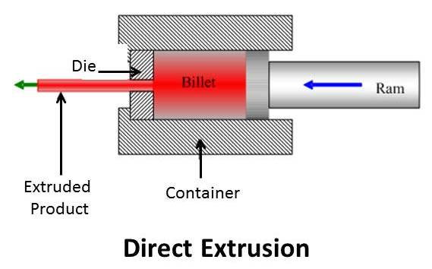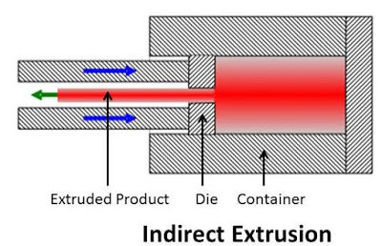 | Solid Extrusion: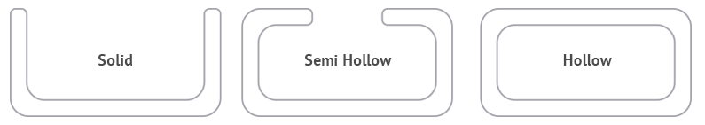  Semi Hollow Extrusion:    Hollow Extrusion:  

TYPES OF EXTRUSIONS
Forward Or Direct Extrusion |  |  | Backeard Or Reverse Or Indirect Extrusion
Advantages | Disadvantages |  | Advantages |  | Disadvantages
Heandaling (Workpiece and structure) is Easy,  Structure is simple. | High Container Wall friction, Required Power & Load are high, Brittle & Semi Brittle materials can’t use because it detoriate Container Wall. |  | Zero Container Wall friction, Required Power & Load are Low, Brittle & Semi Brittle materials can use because Container Wall is zero. |  | Heandaling (Workpiece and structure) is difficult,  Structure is Complex.
Hydrostatic Extrusion |  |  | Impact Extrusion
Advantages |  | Disadvantages | Advantages |  | Disadvantages
Zero Container Wall friction, Required Power & Load are Low, Brittle & Semi Brittle materials can use because Container Wall is zero. |  | Leackage is the issue. | Used to produce very thin sheets e.g. Seamless Tubes, Pepsi Tin bottles, Collapsible tubes, Toothpaste Tubes, etc... |  | Only used for extremely ductile materials e.g. Copper, Aluminium, lead, etc…
Hydrostatic Extrusion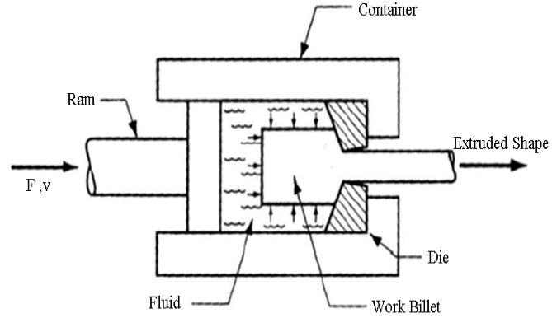 |  |  |  | Impact Extrusion  s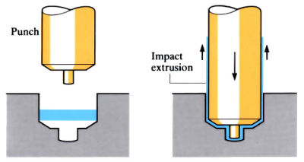

VARIATION OF RAM PRESSURE VS. RAM STROKE:  Due to Cylinder Wall Friction There is variation of friction force as follows,  - Forward Extrusion: Force decreases w.r.t Stroke because container wall friction decreases as the less contact area.  - Backward Extrusion: Force is almost constant.  - Hydrostatic Extrusion: It’s almost same like backward extrusion. | 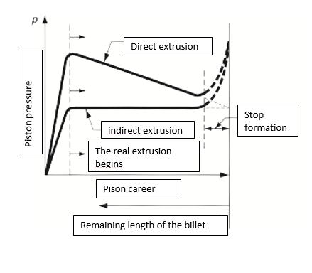
MISCELLANEOUS EXTRUSION PROCESS:
COLD EXTRUSION | HOT EXTRUSION
- Improved mechanical properties resulting from work hardening, provided that the heat generated by plastic deformation and friction does not recrystallize the extruded metal.  - Good control of dimenstional tolerance, reducing the need for subsequent machining or finishing operation.  - Improved surface finish, due to partly to the absence of an oxide film and provided the lubrication is effective.  - Production rates and costs are comparative with those of other methods of producing the same part, such as machining. | - Hot extrusion imvolves prior heating of the billet to a temperature above it’s recrystallization temperature. This reduces strength and increases ductility of the metal, permitting more extreme size reduction and more complex shapes to be achieved in the process.  - Additional advantages include reduction of ram force, increases ram speed, and reduction of grain flow characteristics in the final products.
EXTRUSION PRESSURE AND EXTRUSION LOAD:
- Ideal Extursion (Without fricion and redundant work): Refer Previously Derived Formula.
- Extrusion Pressure by considering friction: By slab analysis (Without Container Wall friction)we can find,
$$σ_{d}=\overline{Υ}\left(\frac{1+β}{β}\right)\left[1-{\left(\frac{A_{1}}{A_{0}}\right)}^{β}\right]$$ | $$Drawing Load F=A_{0}σ_{d}$$  $$β=μ\cot{α}$$
- Actual Extrusion Force:
Johnson Equation (By considerin Container Wall Friction):  $$True Strain ε=a+b\ln\left({A_{0}}/{A_{1}}\right)$$  $$u=\int_{0}^{ε}{σ_{T}dε}=\overline{Υ}ε=\overline{Υ}(a+b\ln\left({A_{0}}/{A_{1}}\right))$$  Work Done on the Wire = $E=A_{0}L_{0}u=A_{0}L_{0}\overline{Υ}[a+b\ln\left({A_{0}}/{A_{1}}\right)]$  Work Done on the Wire = $F L_{0}$  Hence, Ideal Load $F=A_{0}\overline{Υ} \left[a+b\ln\left(K\right)\right]$  Ideal Stress $σ_{d} =\overline{Υ}\left[a+b\ln\left(K\right)\right]=$Ideal Extrusion pressure. | $a$ = Constant = 0.8  $b$ = Constant = 1.2-1.5  For Ideal Plastic,  For Ideal/ Perfectly Plastic Material: $\overline{Υ}=Υ=σ_{yt}$  K = Draft Coefficient,
- Extrusion Force in Hot Extrusion:
Extrusion Load $F=KA_{0} \ln\left({A_{0}}/{A_{1}}\right)$  Extrusion Stress $σ_{d}$ = $K \ln\left(K\right)$ | K= Extrusion Constant (MPa)  =Experimentally measured (Depends on Temp.)
DEFECTS IN EXTRUSION:
Surface Cracking (Bamboo Defect) | Pipe Defect (Fishtail Defect)
Due to friction, crackes generated at Container Wall and flows with extrusion material in the direction of extrusion on the surface. This generates Bamboo Like Structure. To avoid this & Hot shortness use hot working. | Due to impurities present on the suface before extrusion, all impurities comes with extrusion and produces huge pin holes or porous material at centre. And this elongated in the direction of extrsion due to excessve pressure.
Internal Cracking (Centre Burst/ Central Cracking) | 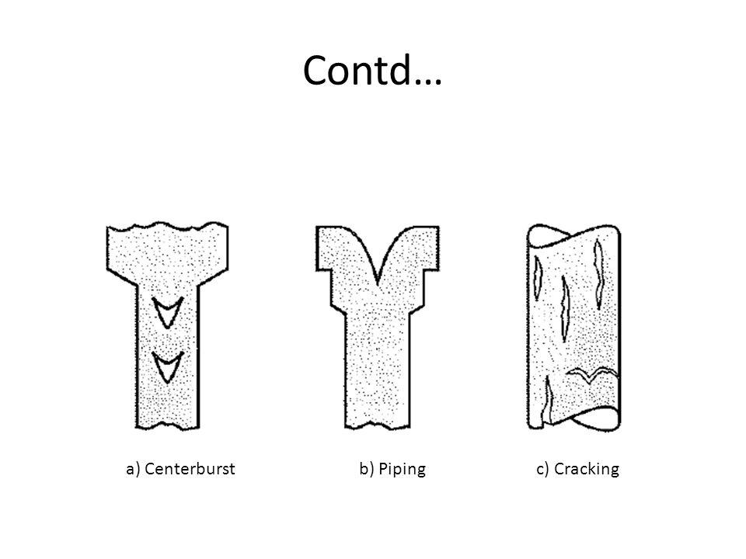
Due to More hydrostatic tension at the centre And Excessive Friction at the surface, Central Cracks Generated. And propogates in the extrusion direction.To avoid this effect, provide lubrication.
HOT SHORTNESS: At temp. below melting point temperature the empurities on the surface melts and sticks to the surface/ Grain Boundary.

FORGING: Forging is a manufacturing process involving the shaping of metal using localized compressive forces. The blows are delivered with a hammer or a die. Here, Grains can be align in required direction. Forging is often classified according to the temperature at which it is performed: cold forging, warm forging, or hot forging.
From volume constancy: $H_{1}=H_{0}{\left({d_{0}}/{d_{1}}\right)}^{2}$ | $$True Strain ε=ln⁡({A_{0}}/{A_{1}})=ln⁡({H_{1}}/{H_{0}})$$
FORGING APPLICATION:

- Automotive engine components
- Turbine Disks
- Gears
- Bolts
- Structural Component for machinery.
- Rail Roads

CLASSIFICATION OF FORGING
BASES ON SOURCE OF FORCED TAKEN (Impact Force)
HAND FORGING | MACHINE FORGING
BASES ON NATURE OR TYPE OF FORCE
PRESS FORGING (Gradually Applied Force) | DROP HAMMER FORGING
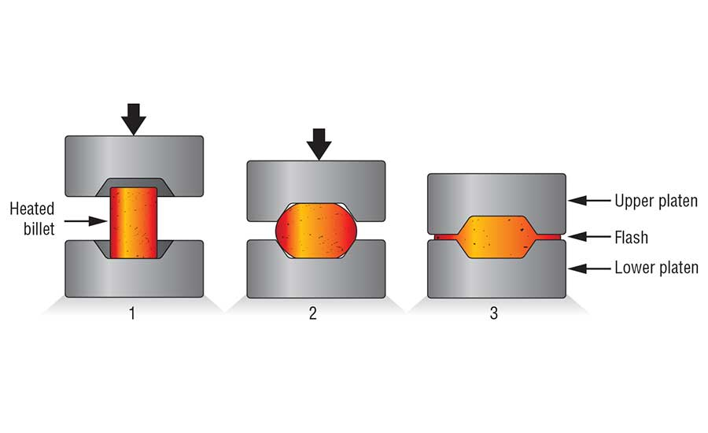 | Impact Load is applied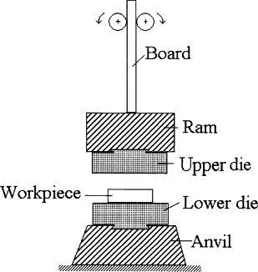
DROP HAMMER FORGING: P.E. = W.D., hence $mgH=F\left(h_{0}-h_{1}\right)$
BASES ON TYPE OF DIE USED
Friction Less (Open/Close (Impression)) Die: Cylindrical Shape is generated.  Without Friction (Open/Close (Impression)) Die: Barrelling Shape is generated due to friction.  1) Sticking Friction, 2) Sliding Friction. |  | 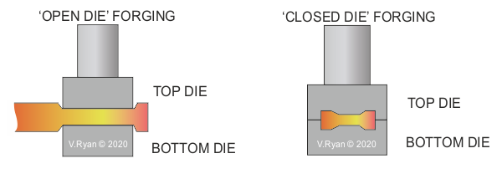
Closed Die Forging:  $${Volume}_{Row Material}=1.2*{Volume}_{Final Product}$$ |  | 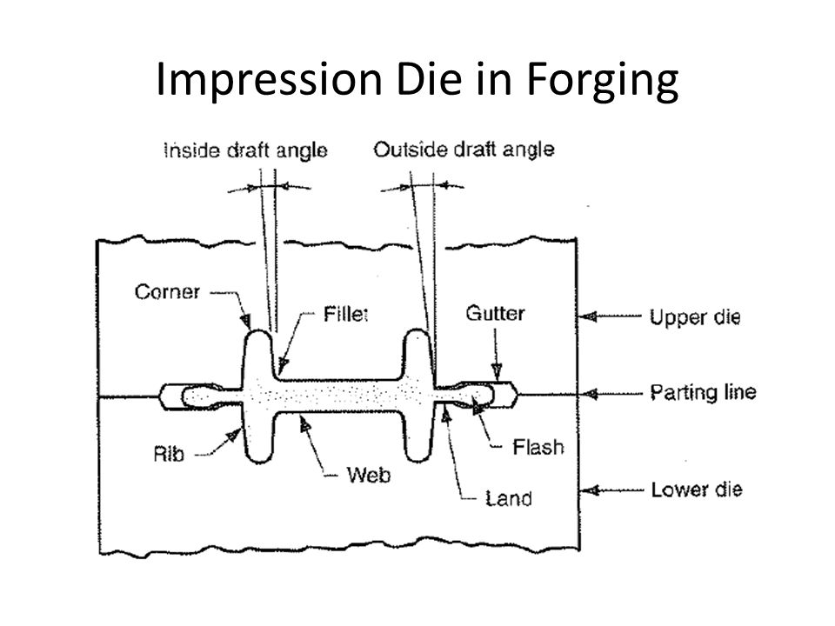
Impression Die | Fleshless Die
Replica Shape Forging  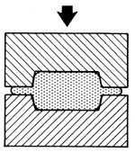 | Precision Forging.  E.g. Coining Operation  More Force is required.  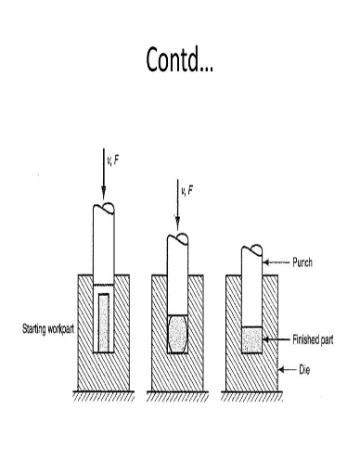
TERMINOLOGY FOR A CONVENTIONAL IMPRESSION DIE FORGING:

- Parting Line/ Flash plane
- Draft
- Web and Ribs
- Fillet and Radii
- Flash Land
- Gutter
Outside Draft Angle is always smaller than the inside draft angle.
Flash Land: It’s become strong and harder due to more heat dissipation from the contacting surface & helps in producing proper shaped component during forging.
STICKING FRICTION | SLIDING FRICTION
Generally, Appears at the centre | Generally, Appears at the outer radius.
This friction generates shear force on the surface and causes barrelling effect.
ANALYSIS:
$$Forging Force∝C/S Area ∝{heigth}^{-1}$$  $$F_{max}={\overline{Υ}}_{1}A_{1}$$  Here, $ε=\ln\left({A_{0}}/{A_{1}}\right)$, $σ_{T}=Kε_{T}^{n}$ and $\overline{Υ}=\frac{Kε_{T}^{n}}{n+1}$ | $F_{max}=$ Forging Force Required,  $A_{1}$ = Area after Forging,  ${\overline{Υ}}_{1}$ = Flow Stress or Yield Stress After Forging

Plane Strain Forging of Flat Rectangular Plate | Forging of Flat Circular Disk
From Distortion Energy Theory, $Υ^{'}=\left(2/{\sqrt{3}}\right)σ_{yt}$  $$X_{s}=a-\frac{h}{2μ}\ln\left(\frac{1}{2μ}\right)$$  Average Pressure Applied or Stress Required for Deformation:  $$P_{avg}=Υ^{'}\left(1+\frac{μa}{h}\right) \& F_{avg}=Υ^{'}\left(1+\frac{μa}{h}\right)A_{1}$$ | $$X_{s}=r-\frac{h}{2μ}\ln\left(\frac{1}{\sqrt{3}μ}\right)$$  Average Pressure Applied or Stress Required for Deformation:  $$P_{avg}=Υ_{1}\left(1+\frac{2μr_{1}}{3h_{1}}\right) \& F_{avg}=Υ_{1}\left(1+\frac{2μr_{1}}{3h_{1}}\right)A_{1}$$
$$0<X<X_{s}…Sticking Fricion$$  $$X_{s}<X<a…Sliding Fricion$$ | $$0<X<X_{s}…Sticking Fricion$$  $$X_{s}<X<r…Sliding Fricion$$
Where, $X_{s}$ = Distance at which Sliding Friction starts,  $a=L/2$, | Where, $X_{s}$ = Distance at which Sliding Friction starts,  r = D/2,
For $μ=0$, $P_{avg}=Υ^{'} \& F_{avg}=Υ^{'}A_{1}$ | For $μ=0$, $P_{avg}=Υ_{1} \& F_{avg}=Υ_{1}A_{1}$
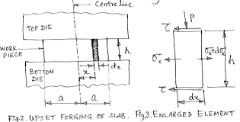
TYPES OF FORGING OPERATIONS:
- Fullering: It’s just Distribution of the material. Convex Dies are used.  - Drawing or Cogging: It’s Distribution of the material along the length direction. Cogging is an open die forging process in which flat or slightly contoured die are employed to compress a work piece, reducing its thickness/ Diameter and increasing its length.  - Upsetting/: Opposite to cogging. Reducing its length/ Height and increasing its thickness/ Diameter.  Open Die Upsetting Closed Die Upsetting  Length < 3 Diameter For L ≥ 3D, $$D_{Cavity}≤1.5 D_{Rod}$$  - Heading: E.g. Head of Bolts can be manufactured. It’s like Upsetting.  - Edging: Opposite to Fullering. It’s just collection of the material in local area. Concave dies are used.  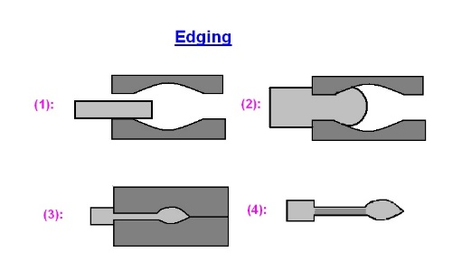 | 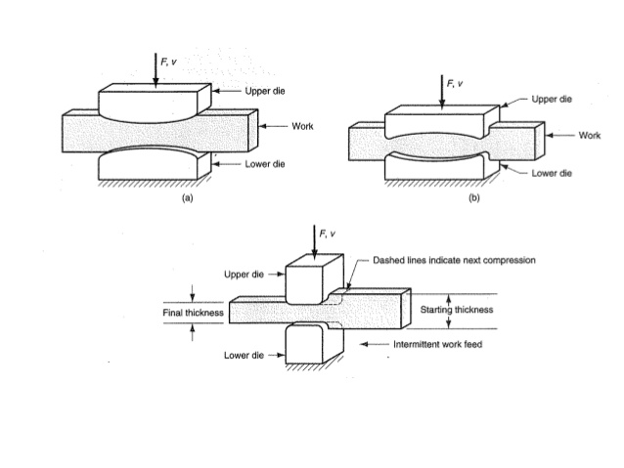  UPSETTING (HEADING)  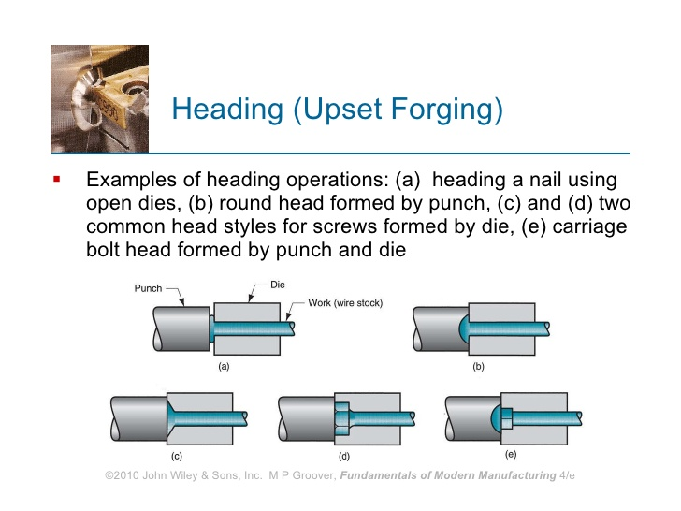
- Flattering: Flatting of the surface as shown in fig.  - Bending: Bending of object in required direction.  - Blocking: Second last stage of the Forging Operation. It’s Semi-final Forging.  - Finishing: Final Shape preparation using Dies.  - Trimming (Cutting off): Removing Flashes from the impressions.  Sequence of impression die forging for a connecting rod:  - Billet  - Pre-shaped  - Rough Forge  - Finishing Die  - Trimming Die | 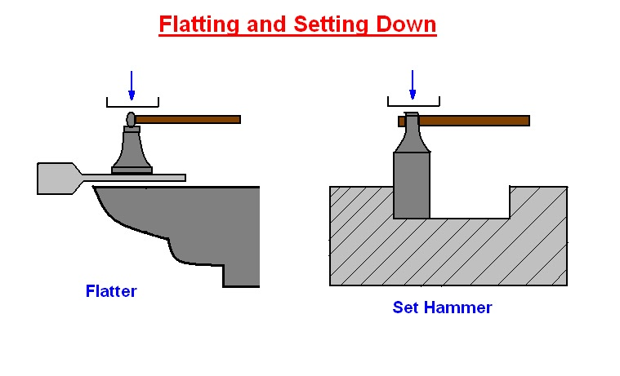  Bending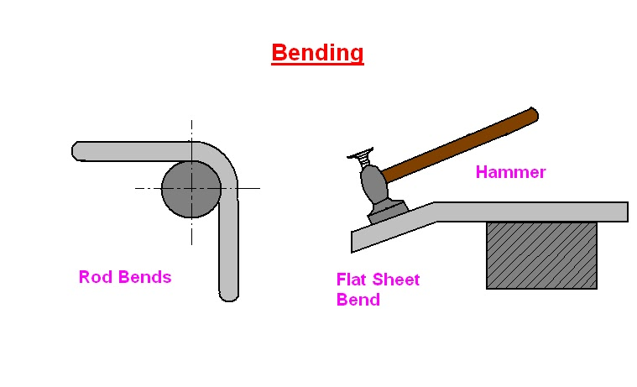   | Steps in forgining operation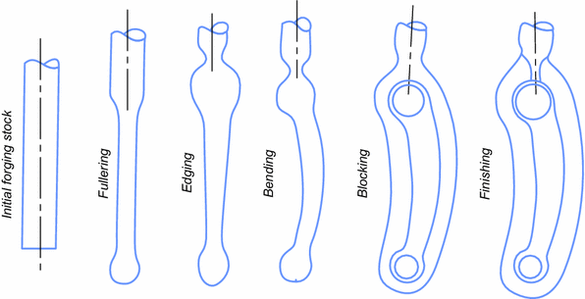
DEFECTS IN FORGING:
- Lap or Buckling (Cold Shut or Fold)  Overlapping of materials and Due to this, bonds are not formed with enough strength.  This Effect present due to backflow/ Circulation of forge material inside die.  - Internal Cracks  - Die Shift: Top and bottom dies are not aligned with each other. To avoid this, dove pin or proper aligning system is used.  - Incomplete Forging Penetration: Material softer in core parts and harder in at forging surface. This happens due to less forge force.  - Unfilled Section: Some portion of die remains unfilled. To avoid this take enough amount of forge volume. | 